GNU Octave, version 3.8.2
Copyright (C) 2014 John W. Eaton and others.
This is free software; see the source code for copying conditions.
There is ABSOLUTELY NO WARRANTY; not even for MERCHANTABILITY or
FITNESS FOR A PARTICULAR PURPOSE. For details, type 'warranty'.

Octave was configured for "x86_64-pc-linux-gnu".

Additional information about Octave is available at http://www.octave.org.

Please contribute if you find this software useful.
For more information, visit http://www.octave.org/get-involved.html

Read http://www.octave.org/bugs.html to learn how to submit bug reports.
For information about changes from previous versions, type 'news'.

a = 1.000000
l = 1.000000
T = 0.200000

ε =
1.0000e-10

n = 10
k = 10
hx = 0.100000
ht = 0.020000

Начальное возмущение =
0.1 * sin(2 * pi * x)

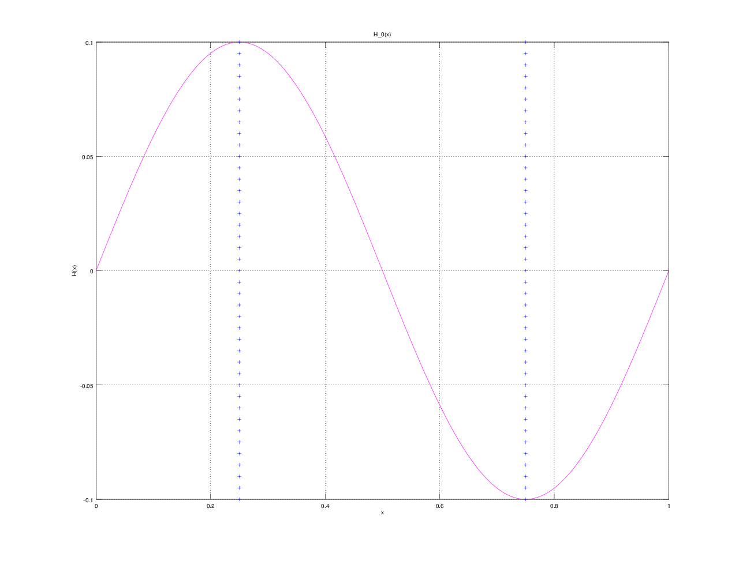

Всего демпферов: 2

Демпфер # 1

x_1 = 0.250000

Верхнее предельное значение w_1(t) =
NaN

Нижнее предельное значение w_1(t) =
NaN

Управляющая функция w_1(t):
1.5807
5.7664
14.1989
10.7087
2.4936
-3.8821
-12.9353
-13.1383
-3.9890
1.1372
2.0999

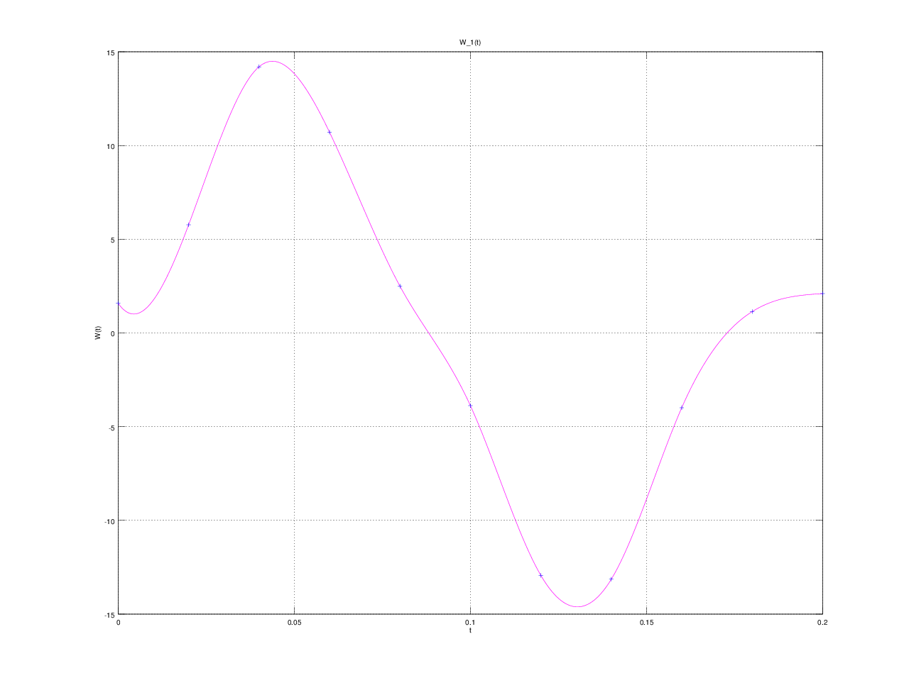

Демпфер # 2

x_2 = 0.750000

Верхнее предельное значение w_2(t) =
NaN

Нижнее предельное значение w_2(t) =
NaN

Управляющая функция w_2(t):
-1.2509
-6.3879
-14.0441
-11.0867
-1.8136
3.5935
13.7290
12.6172
4.3888
-2.0364
-1.4704

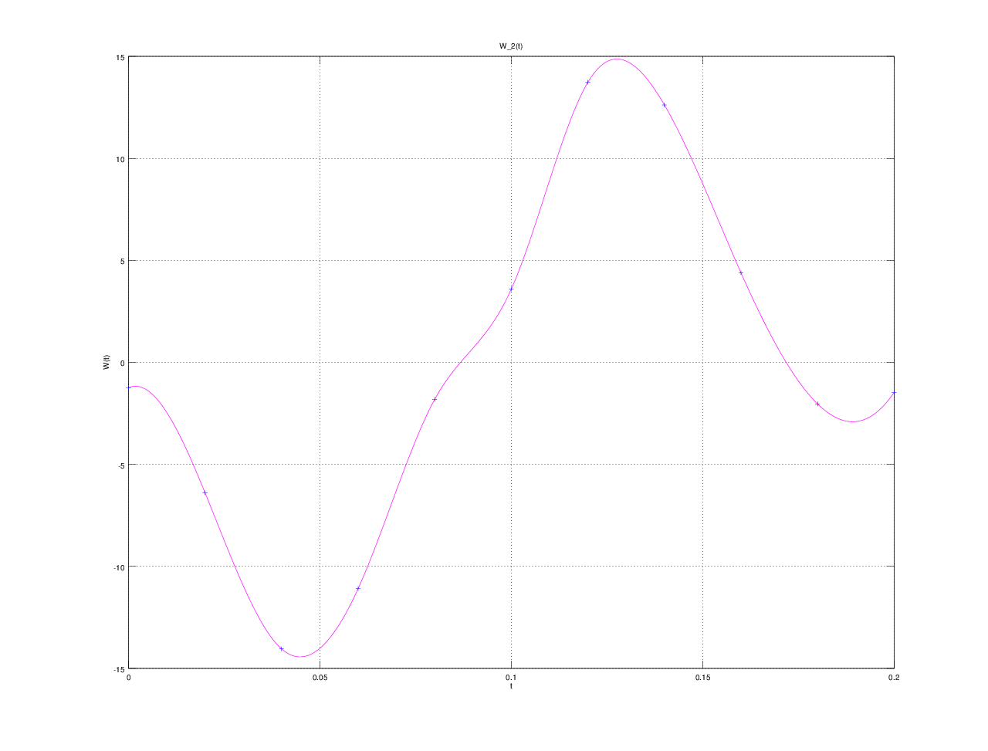

E(T) =
2.1898e-10

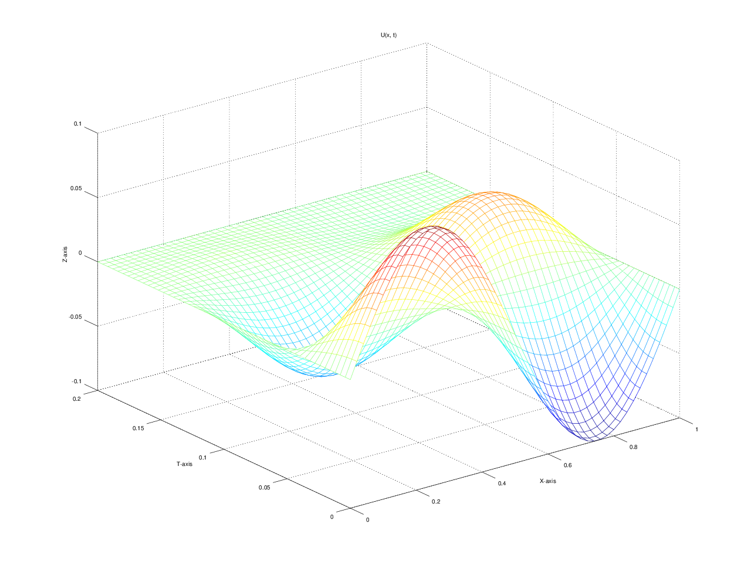

u(x, t)
T = 0.000000: 0.000000 0.058779 0.095106 0.095106 0.058779 0.000000 -0.058779 -0.095106 -0.095106 -0.058779 -0.000000
T = 0.020000: 0.000000 0.045037 0.073339 0.073340 0.045036 -0.000015 -0.045084 -0.073430 -0.073431 -0.045083 0.000000
T = 0.040000: 0.000000 0.013544 0.022956 0.022951 0.013508 -0.000113 -0.013779 -0.023305 -0.023300 -0.013744 0.000000
T = 0.060000: 0.000000 -0.015957 -0.024999 -0.025054 -0.016146 -0.000363 0.015418 0.024350 0.024406 0.015607 0.000000
T = 0.080000: 0.000000 -0.029874 -0.048265 -0.048429 -0.030336 -0.000678 0.029091 0.047468 0.047632 0.029553 0.000000
T = 0.100000: 0.000000 -0.026550 -0.043355 -0.043590 -0.027177 -0.000835 0.025681 0.042528 0.042764 0.026308 0.000000
T = 0.120000: 0.000000 -0.013343 -0.022529 -0.022708 -0.013839 -0.000713 0.012537 0.021721 0.021900 0.013034 0.000000
T = 0.140000: 0.000000 -0.001789 -0.004064 -0.004131 -0.002011 -0.000407 0.001212 0.003392 0.003459 0.001434 0.000000
T = 0.160000: 0.000000 0.001923 0.002941 0.002932 0.001876 -0.000134 -0.002193 -0.003334 -0.003325 -0.002146 0.000000
T = 0.180000: 0.000000 0.001120 0.001945 0.001948 0.001122 -0.000019 -0.001187 -0.002066 -0.002069 -0.001189 0.000000
T = 0.200000: 0.000000 -0.000001 -0.000000 0.000000 -0.000002 -0.000004 -0.000001 -0.000001 -0.000001 -0.000000 0.000000

